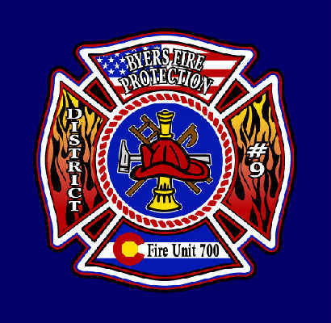

BYERS FIRE PROTECTION DISTRICT #9

100 N. Main Phone – 303.822.5208

P.O. Box 85 Fax – 303.822.5551
Byers, CO 80103 Email – admin@byersfire.org

NOTICE OF PUBLIC HEARING

You are notified that a Petition for Inclusion has been filed with the Board of Directors of the Byers Fire Protection District No. 9 (District) requesting inclusion into the District of the following described property situated in the County of Elbert, State of Colorado.

Section: 3 Township: 6 Range: 61 - B587 P129

A hearing upon said Petition will be held by the Board of Directors of the Byers Fire Protection District No. 9 at 6:30 P.M. on Monday, August 8, 2022, at the Byers Fire Station No. 71, 100 North Main Street, Byers, CO 80103.

The name and address of the Petitioner is as follows:

Arthur A. and Tammra K. Anderson, 47841 County Road 101, Deer Trail, CO 80105

All persons interested shall appear at such time and place and show cause in writing why the Petitions should not be granted.

DATED: July 20, 2022

Byers Fire Protection District No. 9
/s Shawn Palmer, Secretary

