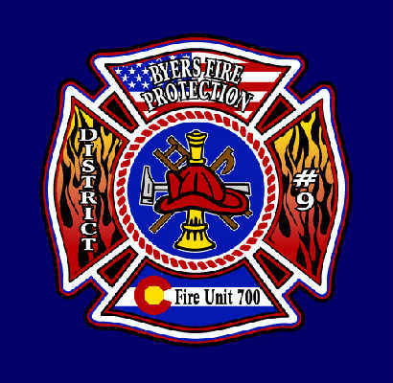

BYERS FIRE PROTECTION DISTRICT #9

100 N. Main Phone – 303.822.5208

P.O. Box 85 Fax – 303.822.5551
Byers, CO 80103 Email – byersfire9@comcast.net

NOTICE OF A GATHERING OF THE BOARD OF DIRECTORS
OF THE BYERS FIRE PROTECTION DISTRICT NO. 9 AND AGENDA

PLEASE TAKE NOTICE that the Board of Directors of the Byers Fire Protection District No. 9 will be gathering for an Awards Banquet and Ceremony on the evening of Saturday, the 7th day of March 2020 at the Byers American Legion located at 278 Front Street, Byers, Colorado.

No business will be conducted at this gathering.

Byers Fire Protection District No. 9
R. James Shelley, Chairman

